# Setting the scene

In this tutorial you will learn how to connect an LCD screen to the Arduino using a breadboard in addition to being able to read a range of different GPS data from the MKR GPS shield.

# Step 1 – Building the circuit

You are going to connect the whole device and then test the LCD screen and GPS sensor separately.

You should first connect the circuit by following the circuit diagram below. Black is ground and Red is 5V. The pin labelled SDA on the Arduino (yellow in this diagram) goes to the SDA pin on the screen. SCL (orange) goes to SCL on the screen.

In order to make the circuit as neat as possible we recommend using shorter length cables where possible and, if possible, plug the screen into the breadboard for extra robustness.. Finally, connect the MKR GPS Shield using the provided cable or, if fitted, using the header pins on the GPS Shield. We found using the header pins is a little more robust as the cable doesn’t get knocked or interfere with anything.

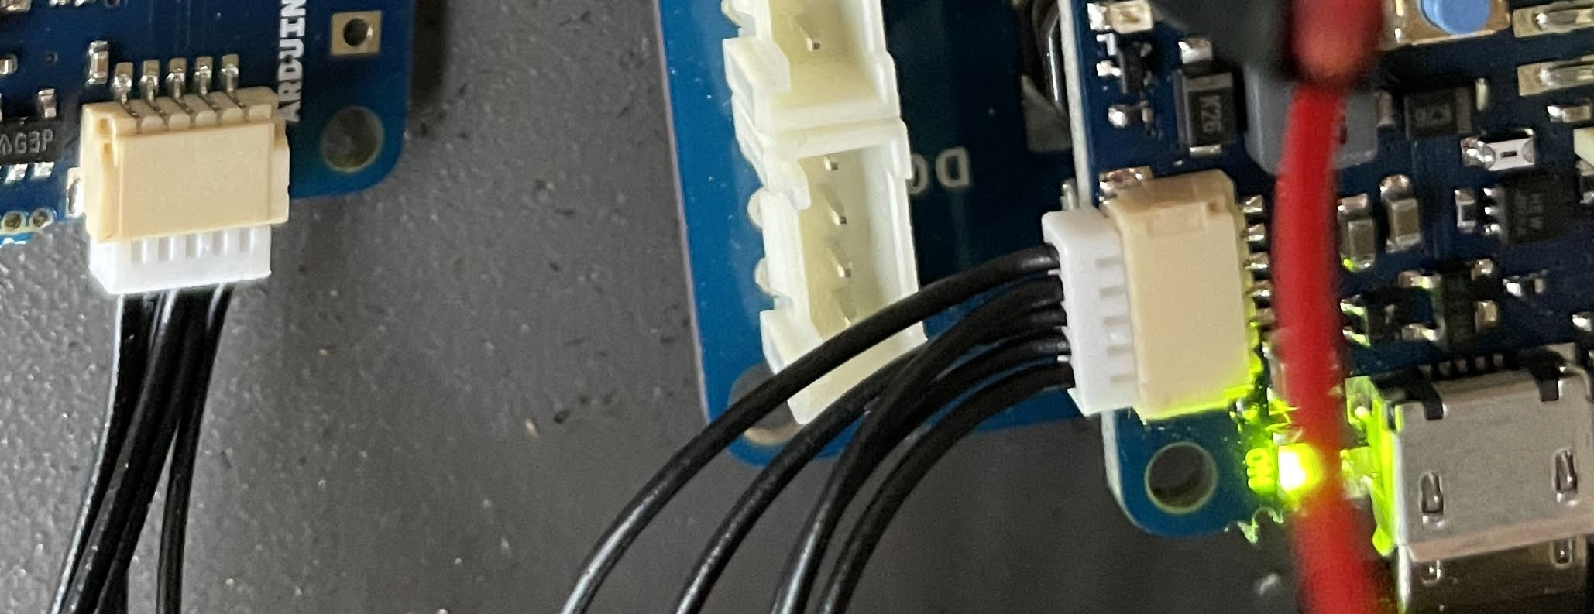

# Testing the LCD screen

To test the LCD Screen is working correctly upload the sample file, LCD_HelloWorld to your Arduino. If it is functioning correctly you should see a greeting printed on the screen. If it’s not functioning correctly check that your cables are connected correctly by following the instructions at the top of this file.

It’s now time to test that you GPS receiver is functioning correctly. You should upload the sample file GPSLocation_sample_no_LCD. If it is working correctly you should see a range of coordinates printed out onto monitor in your IDE.

# Pro-tip

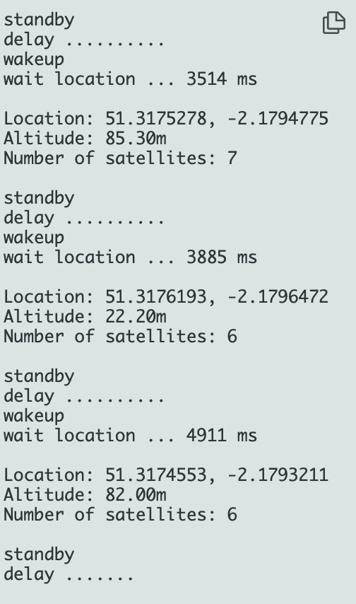If you do not receive GPS data, you should test your device outside as buildings will often stop the GPS signal from being received via the sensor. If you have a laptop, this will work. If not, you will have to wait until you have the LCD working!